**[Project]**

**DETAIL DESIGN DOCUMENT**

**Data design**

**Project Code:**

**Document Code: <Project code>-DD – v<Version>**

1. **Lê Trọng Phú**
2. **Lê Tất Hùng**
3. **Hoàng Huy**
4. **Nguyễn Hữu Tài**

### <Location, issued date of the Document>

**RECORD OF CHANGE**

#### *A - Added M - Modified D – Deleted

|  |  |  |  |  |
| --- | --- | --- | --- | --- |
| Effective Date | Changed Items | A* M, D | Change Description | New Version |
|  |  |  |  |  |
|  |  |  |  |  |
|  |  |  |  |  |
|  |  |  |  |  |
|  |  |  |  |  |
|  |  |  |  |  |
|  |  |  |  |  |
|  |  |  |  |  |
|  |  |  |  |  |
|  |  |  |  |  |

**SIGNATURE PAGE**

**ORIGINATOR:**<Name> <Date>

#### <Position>

**REVIEWERS:** <Name> <Date>

#### <Position>

<Name, if it’s needed> <Date>

<Position>

**APPROVAL:** <Name> <Date>

#### <Position>

MỤC LỤC

# MÔ HÌNH DỮ LIỆU QUAN HỆ

Đưa mô hình dữ liệu quan hệ vào mục này.

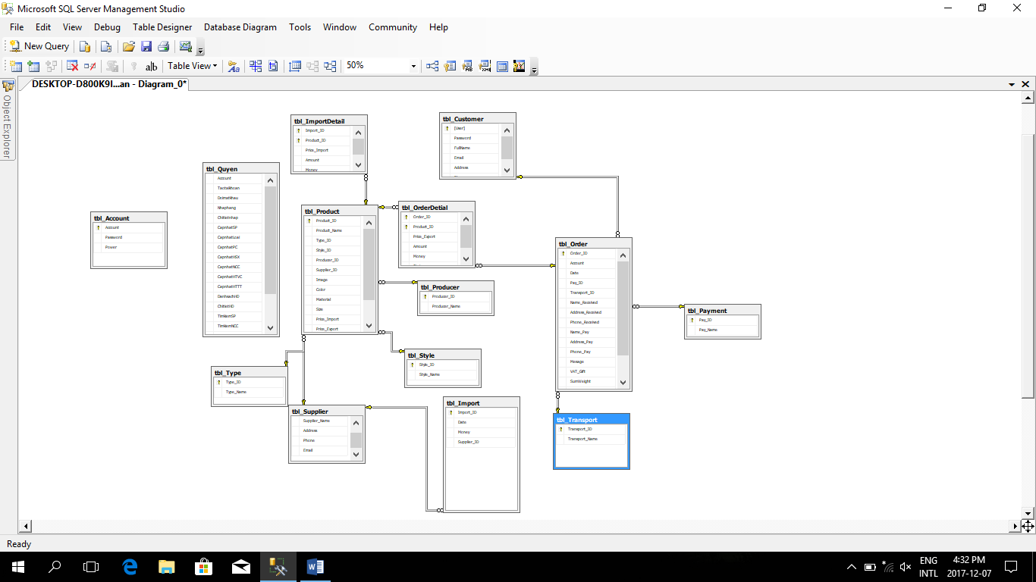

1. **DATABASE**

<List of tables and brief description>

|  |  |  |
| --- | --- | --- |
| **No** | **Table Name** | **Description** |
| 1 | Tbl_Account | Tbl_Account(Account,Password,Power) |
| 2 | Tbl_Customer | Tbl_Customer(User,Password,FullName,Email,Address,Phone) |
| 3 | Tbl_Import | Tbl_Import(Import_ID,Date,Money,Supplier_ID) |
| 4 | Tbl_ImportDetial | Tbl_ImportDetial(Import_ID,Product_ID,Price_Import_Money) |
| 5 | Tbl_Order | Tbl_Order(Order_ID,Accout,Date,Pay_ID,Transport_ID,Name_Pay,Address_Pay,Phone_Pay,Message,VAT_Gift,SumWeight,SumMoney,State) |
| 6 | Tbl_OrderDetial | Tbl_OrderDetial(Order_ID,Product_ID,Price_Export,Amount,Money.state) |
| 7 | Tbl_Payment | Tbl_Payment(Pay_ID,Pay_Name) |
| 8 | Tbl_Producer | Tbl_Producer(Producer_ID,Producer_Name) |
| 9 | Tbl_Product | Tbl_Product(Product_ID,Product_Name,Type_ID,Style_ID,Producer_ID,Supplier_ID,Image,Color,Material,Size,Price_Import,Price_Export,Amount,weight) |
| 10 | Tbl_Quyen | Tbl_Quyen(Account,Taotaikhoan,Doimatkhau,Nhaphang,Chitietnhap,CapnhapSP,CapNhaploai,CapnhapPC,CapnhapHSX,CapnhapNCC,CapnhapHTVC,CapnhapHTTT,DanhSachHD,ChitietHoaDon,TiemKiemsanpham,thongkesanpham,thongkedhn,thongkedoanhthu,thongkesanphambanchay hhat) |
| 11 | Tbl_Style | Tbl_Style(Style_ID,Style_Name) |
| 12 | Tbl_Supplier | Tbl_Supplier(Supplier,Supplier_Name,Address,Phone,Email) |
| 13 | Tbl_Transport | Tbl_Transport(TranSport_ID,Transport_Name) |
| 14 | Tbl_Type | Tbl_Type(Type_ ID, Type _Name) |

## Table Tbl_Account

|  |  |  |  |  |  |  |  |  |  |  |
| --- | --- | --- | --- | --- | --- | --- | --- | --- | --- | --- |
| **No** | **Field Name** | **Type** | **Length** | **Size** | **Null** | **Unique** | **P/F Key** | **Default** | **Check** | **Description** |
| 01 | Account | varchar | 50 |  | x |  | P |  |  |  |
| 02 | Password | varchar | 50 |  |  |  |  |  |  |  |
| 03 | Power | nvarchar | 50 |  |  |  |  |  |  |  |

**2.2 table** Tbl_Customer

|  |  |  |  |  |  |  |  |  |  |  |
| --- | --- | --- | --- | --- | --- | --- | --- | --- | --- | --- |
| **No** | **Field Name** | **Type** | **Length** | **Size** | **Null** | **Unique** | **P/F Key** | **Default** | **Check** | **Description** |
| 01 | User | varchar | 20 |  | x |  | P |  |  |  |
| 02 | Password | varchar | 20 |  |  |  |  |  |  |  |
| 03 | FullName | nvarchar | 50 |  |  |  |  |  |  |  |
| 04 | Email | Varchar | 50 |  |  |  |  |  |  |  |
| 05 | Address | Nvarchar | 100 |  |  |  |  |  |  |  |
| 06 | Phone | int |  |  |  |  |  |  |  |  |

**2.3 S** Tbl_Import

|  |  |  |  |  |  |  |  |  |  |  |
| --- | --- | --- | --- | --- | --- | --- | --- | --- | --- | --- |
| **No** | **Field Name** | **Type** | **Length** | **Size** | **Null** | **Unique** | **P/F Key** | **Default** | **Check** | **Description** |
| 1 | Import_ID | int |  |  | x |  | P |  |  |  |
| 2 | Date | datetime |  |  |  |  |  |  |  |  |
| 3 | Money | float |  |  |  |  |  |  |  |  |
| 4 | Supplier_ID | FK |  |  |  |  | F |  |  |  |

**2.4** Tbl_ImportDetial

|  |  |  |  |  |  |  |  |  |  |  |
| --- | --- | --- | --- | --- | --- | --- | --- | --- | --- | --- |
| **No** | **Field Name** | **Type** | **Length** | **Size** | **Null** | **Unique** | **P/F Key** | **Default** | **Check** | **Description** |
| 01 | Import_ID | int |  |  | x |  | P |  |  |  |
| 02 | Product_ID | int |  |  |  |  | F |  |  |  |
| 03 | Price_Import | float |  |  |  |  |  |  |  |  |
| 04 | Amount | Int |  |  |  |  |  |  |  |  |
| 05 | Money | float |  |  |  |  |  |  |  |  |

**2.5** Tbl_Order

|  |  |  |  |  |  |  |  |  |  |  |
| --- | --- | --- | --- | --- | --- | --- | --- | --- | --- | --- |
| **No** | **Field Name** | **Type** | **Length** | **Size** | **Null** | **Unique** | **P/F Key** | **Default** | **Check** | **Description** |
| 01 | Order | nchar | 10 |  | x |  | P |  |  |  |
| 02 | Account | varchar | 20 |  |  |  | F |  |  |  |
| 03 | Date | datetime |  |  |  |  |  |  |  |  |
| 04 | Pay_ID | int |  |  |  |  | F |  |  |  |
| 05 | Transport_ID | int |  |  |  |  | F |  |  |  |
| 06 | Name_received | Nvarchar | 50 |  |  |  |  |  |  |  |
| 07 | Addpress_ received | Nvarchar | 50 |  |  |  |  |  |  |  |
| 08 | Phone_ received | int |  |  |  |  |  |  |  |  |
| 09 | Name_Pay | Nvarchar | 50 |  |  |  |  |  |  |  |
| 10 | Addpress_Pay | Nvarchar | 50 |  |  |  |  |  |  |  |
| 11 | Phone_Pay | int |  |  |  |  |  |  |  |  |
| 12 | Message | Nvarchar | max |  |  |  |  |  |  |  |
| 13 | VAT_Gift | Float |  |  |  |  |  |  |  |  |
| 14 | SumWeight | Float |  |  |  |  |  |  |  |  |
| 15 | VAT_Transport | Float |  |  |  |  |  |  |  |  |
| 16 | SumMoney | float |  |  |  |  |  |  |  |  |
| 17 |  |  |  |  |  |  |  |  |  |  |
|  |  |  |  |  |  |  |  |  |  |  |

**2.6 loai san pham**

|  |  |  |  |  |  |  |  |  |  |  |
| --- | --- | --- | --- | --- | --- | --- | --- | --- | --- | --- |
| **No** | **Field Name** | **Type** | **Length** | **Size** | **Null** | **Unique** | **P/F Key** | **Default** | **Check** | **Description** |
| 01 | maLoai | nvarchar | 50 |  | x |  | P |  |  |  |
| 02 | tenLoai | navrchar | 50 |  |  |  |  |  |  |  |

**2.7 size**

|  |  |  |  |  |  |  |  |  |  |  |
| --- | --- | --- | --- | --- | --- | --- | --- | --- | --- | --- |
| **No** | **Field Name** | **Type** | **Length** | **Size** | **Null** | **Unique** | **P/F Key** | **Default** | **Check** | **Description** |
| **01** | **maSize** | **nvarchar** | **50** |  | **x** |  | **P** |  |  |  |
| 02 | tenSize | navrchar | 50 |  |  |  |  |  |  |  |

**2.8 hoa don**

|  |  |  |  |  |  |  |  |  |  |  |
| --- | --- | --- | --- | --- | --- | --- | --- | --- | --- | --- |
| **No** | **Field Name** | **Type** | **Length** | **Size** | **Null** | **Unique** | **P/F Key** | **Default** | **Check** | **Description** |
| 01 | maHoaDon | nvarchar | 50 |  | x |  | P |  |  |  |
| 02 | tenHoaDon | navrchar | 50 |  |  |  |  |  |  |  |
| 03 | maCT |  |  |  |  |  | F |  |  |  |
| 04 | maKhachHang |  |  |  |  |  | F |  |  |  |
| 05 | tongGia |  |  |  |  |  |  |  |  |  |

**2.9 Khach hang**

|  |  |  |  |  |  |  |  |  |  |  |
| --- | --- | --- | --- | --- | --- | --- | --- | --- | --- | --- |
| **No** | **Field Name** | **Type** | **Length** | **Size** | **Null** | **Unique** | **P/F Key** | **Default** | **Check** | **Description** |
| 01 | maKhachHang | nvarchar | 50 |  | x |  | P |  |  |  |
| 02 | tenKhachHang | navrchar | 50 |  |  |  |  |  |  |  |
| 03 | namSinh |  |  |  |  |  |  |  |  |  |
| 04 | SDT |  |  |  |  |  |  |  |  |  |

**2.10 chi tiet**

|  |  |  |  |  |  |  |  |  |  |  |
| --- | --- | --- | --- | --- | --- | --- | --- | --- | --- | --- |
| **No** | **Field Name** | **Type** | **Length** | **Size** | **Null** | **Unique** | **P/F Key** | **Default** | **Check** | **Description** |
| 01 | maChiTiet | nvarchar | 50 |  | x |  | P |  |  |  |
| 02 | tenSanPham | navrchar | 50 |  |  |  |  |  |  |  |
|  |  |  |  |  |  |  |  |  |  |  |
|  |  |  |  |  |  |  |  |  |  |  |